Computer Architecture Course: IT089IU

International University – VNU HCM Date: March 2021

Dr. Le Hai Duong & Dr. Ly Tu Nga Time: 6 hours

**Laboratory Session 7**

**Lê Thanh Phương Nam ITITUN19008**

**Excersise 1:**

**Code:**

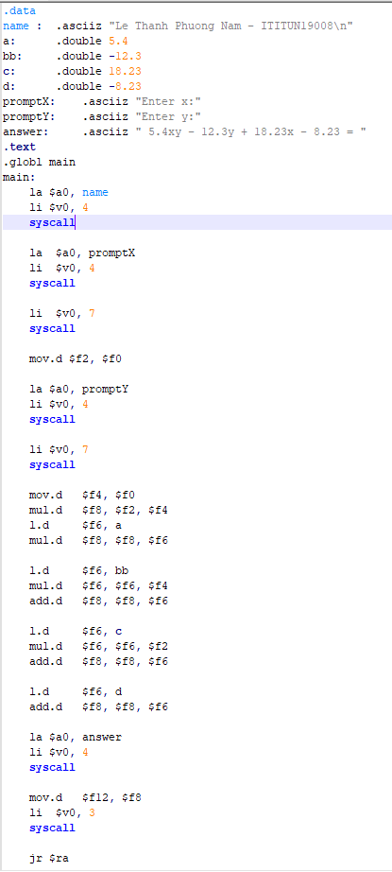

**Running:**

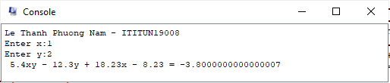

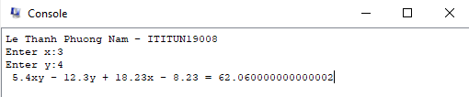

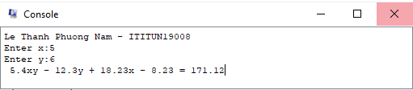

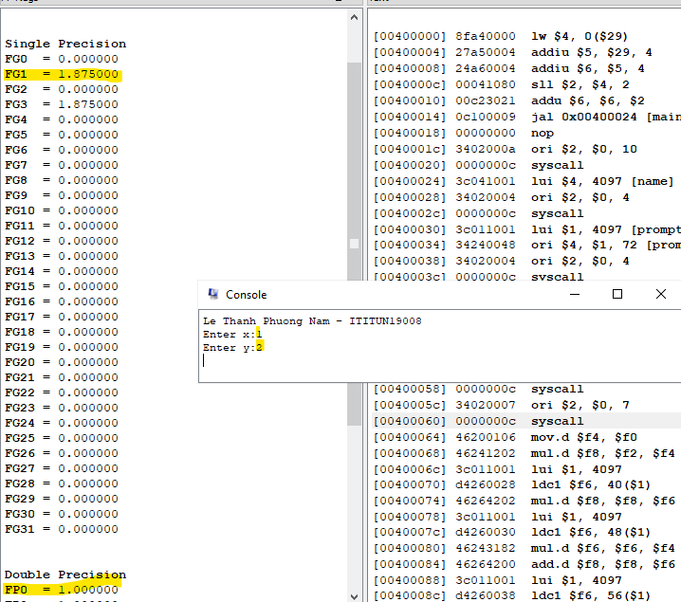

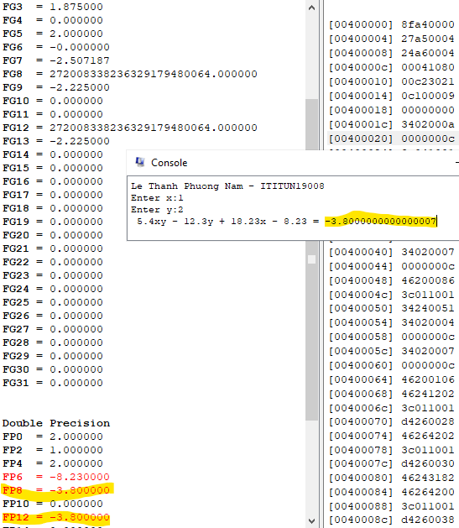

**Excersise 2:**

**Code:**

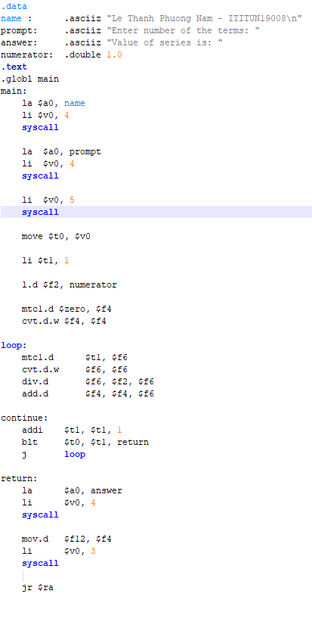

**Running:**

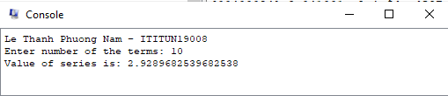

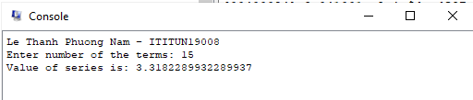

t0 = 10, t1 starting at 0 and ascending to 11

t0 =15, t1 starting at 0 and ascending to 16

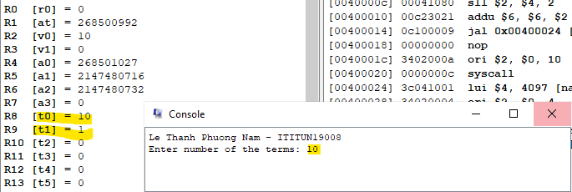

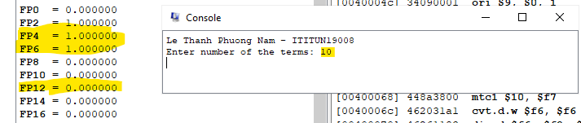

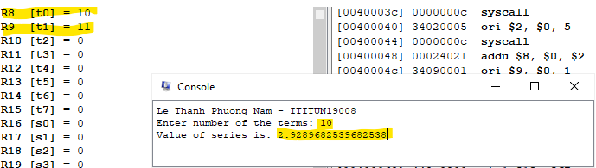

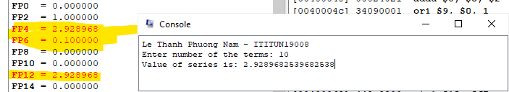

**Excersise 3:**

**Code:**

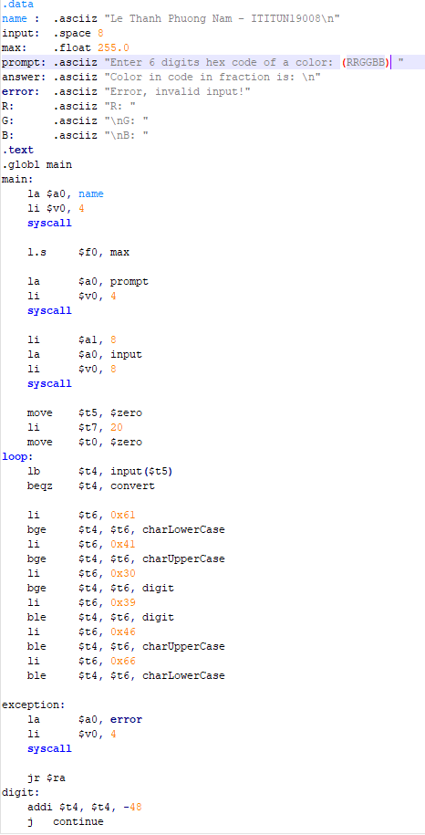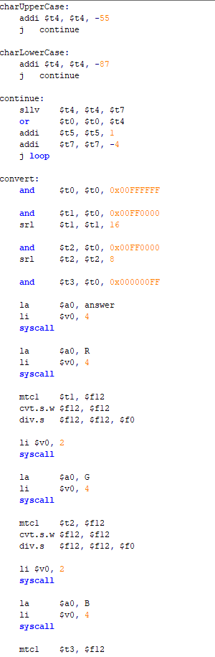

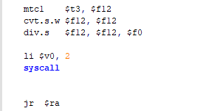

**Running:**

